3B Measurement – Lesson 4
Applications of Perimeter, Area and Volume.
Area, Perimeter of Irregular Blocks.

Name: _________________

- Use the Surveyor’s Notepad to make a sketch of the irregular block of land.

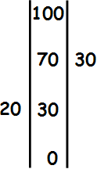

  - Find the area of the above irregular block.

    - Label the left triangle T₁ and calculate its area [A = 0.5 x b x h].

    - Label the right triangle T₂ and calculate its area [A = 0.5 x b x h].

    - Add the areas of T₁ and T₂ to find the total area.

  - Use Pythagoras Theorem to find the length of each side. [c²=a²+b²]

- Top Left  c² = 70² + 20²  c² = 5300 (Take square root)  c ≈ 73 m | - Top Right
- Bottom Left | - Bottom Right
    - Perimeter = Top Left + Top Right + Bottom Left + Bottom Right

= ____ + ____ + ____ + ____ = ____ m

- Use the Surveyor’s Notepad to make a sketch of the block of land.

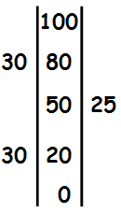

  - Find the area of the above irregular block.

    - Label the top left triangle T₁ and calculate its area [A = 0.5 x b x h].

    - Label the bottom left triangle T₂ and calculate its area [A = 0.5 x b x h].

    - Label the right triangle T₃ and calculate its area [A = 0.5 x b x h].

    - Label the rectangle R₁ and calculate its area [A = L x B].

    - Add the areas T₁, T₂, T₃ and R₁ to find the total area.

- Use Simpson’s Rule to find the approximate are between the curve and the line.
A ≈ h÷3 x (d_{F} +4d_{M} + d_{L})
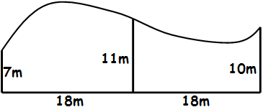

- Use Simpson’s Rule to find the approximate are between the curve and the line.

